CHAPTER 6: RISK AVERSION AND
CAPITAL ALLOCATION TO RISKY ASSETS

PROBLEM SETS

1. (d) While a higher or lower Sharpe ratios are not an indication of an investor's tolerance for risk, any investor will always prefer investment portfolios with higher Sharpe ratios. The Sharpe ratio is simply a tool to absolutely measure the return premium earned per unit of risk.

2. (b) A higher borrowing rate is a consequence of the risk of the borrowers’ default. In perfect markets with no additional cost of default, this increment would equal the value of the borrower’s option to default, and the Sharpe measure, with appropriate treatment of the default option, would be the same. However, in reality there are costs to default so that this part of the increment lowers the Sharpe ratio. Also, notice that answer (c) is not correct because doubling the expected return with a fixed risk-free rate will more than double the risk premium and the Sharpe ratio.

3. Assuming no change in risk tolerance, that is, an unchanged risk-aversion coefficient (A), higher perceived volatility increases the denominator of the equation for the optimal investment in the risky portfolio (Equation 6.7). The proportion invested in the risky portfolio will therefore decrease.

4. a. The expected cash flow is: (0.5 × $70,000) + (0.5 × 200,000) = $135,000.
With a risk premium of 8% over the risk-free rate of 6%, the required rate of return is 14%. Therefore, the present value of the portfolio is:
$135,000/1.14 = $118,421

b. If the portfolio is purchased for $118,421 and provides an expected cash inflow of $135,000, then the expected rate of return [E(r)] is as follows:
$118,421 × [1 + E(r)] = $135,000
Therefore, E(r) = 14%. The portfolio price is set to equate the expected rate of return with the required rate of return.

c. If the risk premium over T-bills is now 12%, then the required return is:
6% + 12% = 18%
The present value of the portfolio is now:
$135,000/1.18 = $114,407

d. For a given expected cash flow, portfolios that command greater risk premiums must sell at lower prices. The extra discount from expected value is a penalty for risk.

- When we specify utility by U = E(r) – 0.5Aσ^{ 2}, the utility level for T-bills is: 0.07
The utility level for the risky portfolio is:
U = 0.12 – 0.5 × A × (0.18)² = 0.12 – 0.0162 × A
In order for the risky portfolio to be preferred to bills, the following must hold:
0.12 – 0.0162A > 0.07 ⇒ A < 0.05/0.0162 = 3.09
A must be less than 3.09 for the risky portfolio to be preferred to bills.

6. Points on the curve are derived by solving for E(r) in the following equation:
U = 0.05 = E(r) – 0.5Aσ² = E(r) – 1.5σ²
The values of E(r), given the values of σ², are therefore:
σ | σ ² | E(r)
0.00 | 0.0000 | 0.05000
0.05 | 0.0025 | 0.05375
0.10 | 0.0100 | 0.06500
0.15 | 0.0225 | 0.08375
0.20 | 0.0400 | 0.11000
0.25 | 0.0625 | 0.14375
The bold line in the graph on the next page (labeled Q6, for Question 6) depicts the indifference curve.

7. Repeating the analysis in Problem 6, utility is now:
U = E(r) – 0.5Aσ² = E(r) – 2.0σ² = 0.05
The equal-utility combinations of expected return and standard deviation are presented in the table below. The indifference curve is the upward sloping line in the graph on the next page, labeled Q7 (for Question 7).
σ | σ ² | E(r)
0.00 | 0.0000 | 0.0500
0.05 | 0.0025 | 0.0550
0.10 | 0.0100 | 0.0700
0.15 | 0.0225 | 0.0950
0.20 | 0.0400 | 0.1300
0.25 | 0.0625 | 0.1750

The indifference curve in Problem 7 differs from that in Problem 6 in slope. When A increases from 3 to 4, the increased risk aversion results in a greater slope for the indifference curve since more expected return is needed in order to compensate for additional σ.

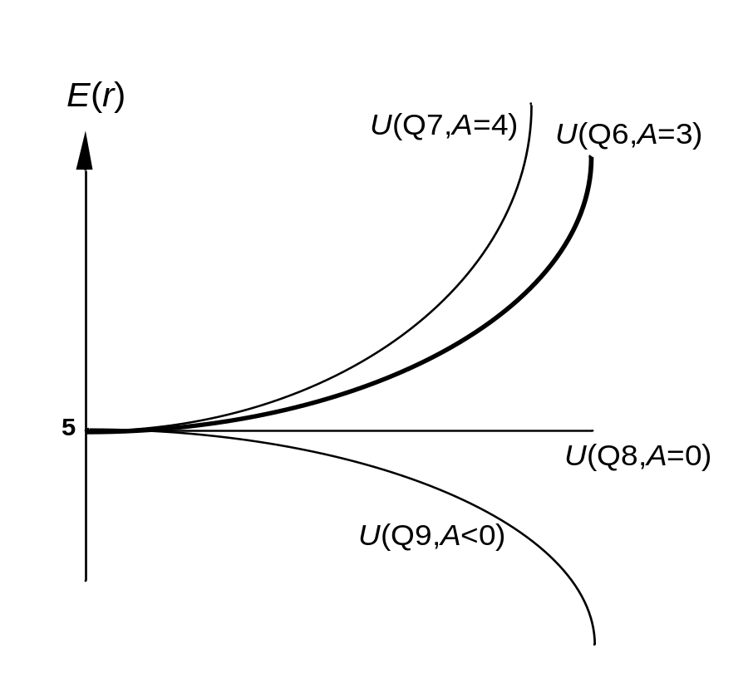

8. The coefficient of risk aversion for a risk neutral investor is zero. Therefore, the corresponding utility is equal to the portfolio’s expected return. The corresponding indifference curve in the expected return-standard deviation plane is a horizontal line, labeled Q8 in the graph above (see Problem 6).

9. A risk lover, rather than penalizing portfolio utility to account for risk, derives greater utility as variance increases. This amounts to a negative coefficient of risk aversion. The corresponding indifference curve is downward sloping in the graph above (see Problem 6), and is labeled Q9.

10. The portfolio expected return and variance are computed as follows:
(1)  W_{Bills} | (2)  r_{Bills} | (3)  W_{Index} | (4)  r_{Index} | r_{Portfolio}  (1)×(2)+(3)×(4) | σ_{Portfolio}  (3) × 20% | σ ² _{Portfolio}
0.0 | 5% | 1.0 | 13.0% | 13.0% = 0.130 | 20% = 0.20 | 0.0400
0.2 | 5 | 0.8 | 13.0 | 11.4% = 0.114 | 16% = 0.16 | 0.0256
0.4 | 5 | 0.6 | 13.0 | 9.8% = 0.098 | 12% = 0.12 | 0.0144
0.6 | 5 | 0.4 | 13.0 | 8.2% = 0.082 | 8% = 0.08 | 0.0064
0.8 | 5 | 0.2 | 13.0 | 6.6% = 0.066 | 4% = 0.04 | 0.0016
1.0 | 5 | 0.0 | 13.0 | 5.0% = 0.050 | 0% = 0.00 | 0.0000

11. Computing utility from U = E(r) – 0.5 × Aσ² = E(r) – σ², we arrive at the values in the column labeled U(A = 2) in the following table:
W_{Bills} | W_{Index} | r_{Portfolio} | σ_{Portfolio} | σ²_{Portfolio} | U(A = 2) | U(A = 3)
0.0 | 1.0 | 0.130 | 0.20 | 0.0400 | 0.0900 | .0700
0.2 | 0.8 | 0.114 | 0.16 | 0.0256 | 0.0884 | .0756
0.4 | 0.6 | 0.098 | 0.12 | 0.0144 | 0.0836 | .0764
0.6 | 0.4 | 0.082 | 0.08 | 0.0064 | 0.0756 | .0724
0.8 | 0.2 | 0.066 | 0.04 | 0.0016 | 0.0644 | .0636
1.0 | 0.0 | 0.050 | 0.00 | 0.0000 | 0.0500 | .0500
The column labeled U(A = 2) implies that investors with A = 2 prefer a portfolio that is invested 100% in the market index to any of the other portfolios in the table.

12. The column labeled U(A = 3) in the table above is computed from:
U = E(r) – 0.5Aσ² = E(r) – 1.5σ²
The more risk averse investors prefer the portfolio that is invested 40% in the market, rather than the 100% market weight preferred by investors with A = 2.

13. Expected return = (0.7 × 18%) + (0.3 × 8%) = 15%
Standard deviation = 0.7 × 28% = 19.6%

14. | Investment proportions: |  | 30.0% in T-bills
 |  | 0.7 × 25% = | 17.5% in Stock A
 |  | 0.7 × 32% = | 22.4% in Stock B
 |  | 0.7 × 43% = | 30.1% in Stock C

15. Your reward-to-volatility (Sharpe) ratio: 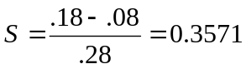
Client's reward-to-volatility (Sharpe) ratio: 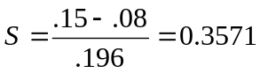

16.
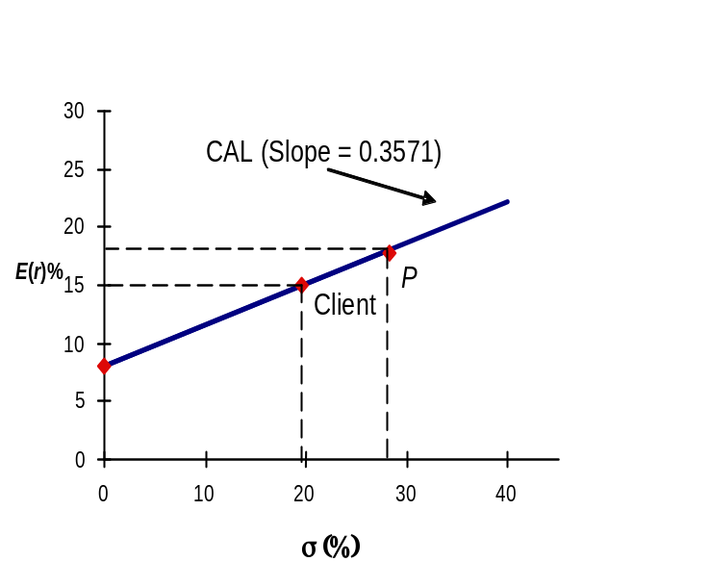

17. a. E(r_{C}) = r_{f} + y × [E(r_{P}) – r_{f}] = 8 + y × (18 − 8)
If the expected return for the portfolio is 16%, then:
16% = 8% + 10% × y ⇒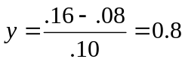
Therefore, in order to have a portfolio with expected rate of return equal to 16%, the client must invest 80% of total funds in the risky portfolio and 20% in T-bills.

b.
Client’s investment proportions: |  | 20.0% in T-bills
 | 0.8 × 25% = | 20.0% in Stock A
 | 0.8 × 32% = | 25.6% in Stock B
 | 0.8 × 43% = | 34.4% in Stock C

c. σ_{C} = 0.8 × σ_{P} = 0.8 × 28% = 22.4%

18. a. σ_{C} = y × 28%
If your client prefers a standard deviation of at most 18%, then:
y = 18/28 = 0.6429 = 64.29% invested in the risky portfolio.

b.

19. a. y*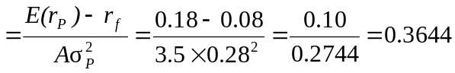
Therefore, the client’s optimal proportions are: 36.44% invested in the risky portfolio and 63.56% invested in T-bills.

- E(r_{C}) = 0.08 + 0.10 × y* = 0.08 + (0.3644 × 0.1) = 0.1164 or 11.644%
σ_{C} = 0.3644 × 28 = 10.203%

20. a. If the period 1926–2015 is assumed to be representative of future expected performance, then we use the following data to compute the fraction allocated to equity: A = 4, E(r_{M}) − r_{f} = 8.30%, σ_{M} = 20.59% (we use the standard deviation of the risk premium from Table 6.7). Then y* is given by:

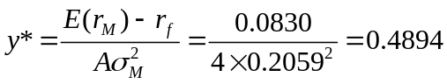

That is, 48.94% of the portfolio should be allocated to equity and 51.06% should be allocated to T-bills.

- If the period 1970–1991 is assumed to be representative of future expected performance, then we use the following data to compute the fraction allocated to equity: A = 4, E(r_{M}) − r_{f} = 5.33%, σ_{M} = 18.20% and y* is given by:
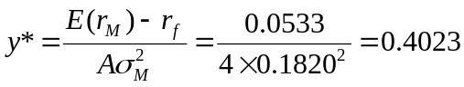

Therefore, 40.23% of the complete portfolio should be allocated to equity and 59.77% should be allocated to T-bills.

c. In part (b), the market risk premium is expected to be lower than in part (a) and market risk is higher. Therefore, the reward-to-volatility ratio is expected to be lower in part (b), which explains the greater proportion invested in T-bills.

21. a. E(r_{C}) = 8% = 5% + y × (11% – 5%) ⇒ 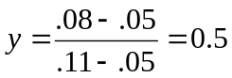

b. σ_{C} = y × σ_{P} = 0.50 × 15% = 7.5%

c. The first client is more risk averse, preferring investments that have less risk as evidenced by the lower standard deviation.

22. Johnson requests the portfolio standard deviation to equal one half the market portfolio standard deviation. The market portfolio 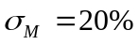, which implies 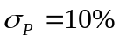. The intercept of the CML equals 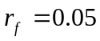and the slope of the CML equals the Sharpe ratio for the market portfolio (35%). Therefore using the CML:
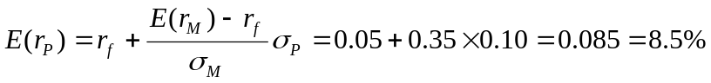
23. Data: r_{f} = 5%, E(r_{M}) = 13%, σ_{M} = 25%, and 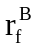= 9%
The CML and indifference curves are as follows:
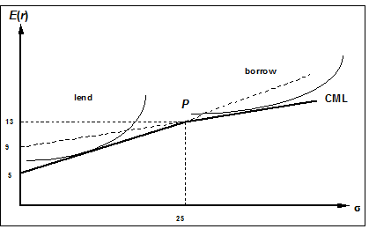

24. For y to be less than 1.0 (that the investor is a lender), risk aversion (A) must be large enough such that:
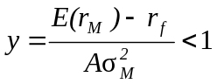 ⇒ 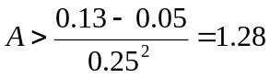
For y to be greater than 1 (the investor is a borrower), A must be small enough:
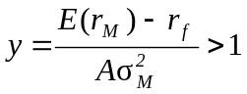 ⇒ 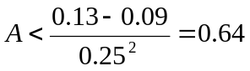
For values of risk aversion within this range, the client will neither borrow nor lend but will hold a portfolio composed only of the optimal risky portfolio:
y = 1 for 0.64 ≤ A ≤ 1.28

25. a. The graph for Problem 23 has to be redrawn here, with:
E(r_{P}) = 11% and σ_{P} = 15%
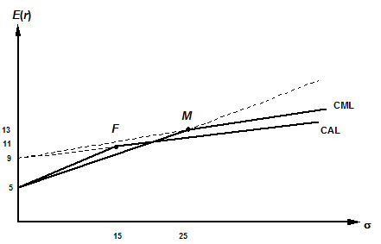
b. For a lending position: 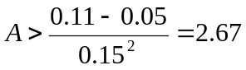
For a borrowing position: 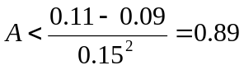
Therefore, y = 1 for 0.89 ≤ A ≤ 2.67

26. The maximum feasible fee, denoted f, depends on the reward-to-variability ratio.
For y < 1, the lending rate, 5%, is viewed as the relevant risk-free rate, and we solve for f as follows:
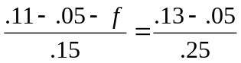 ⇒ 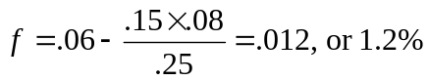
For y > 1, the borrowing rate, 9%, is the relevant risk-free rate. Then we notice that, even without a fee, the active fund is inferior to the passive fund because:
.11 – .09 – f | = 0.13 < | .13 – .09 | = 0.16 → f = –.004
.15 | = 0.13 < | .25 | = 0.16 → f = –.004
More risk tolerant investors (who are more inclined to borrow) will not be clients of the fund. We find that f is negative: that is, you would need to pay investors to choose your active fund. These investors desire higher risk–higher return complete portfolios and thus are in the borrowing range of the relevant CAL. In this range, the reward-to-variability ratio of the index (the passive fund) is better than that of the managed fund.

27. a. Slope of the CML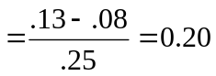
The diagram follows.
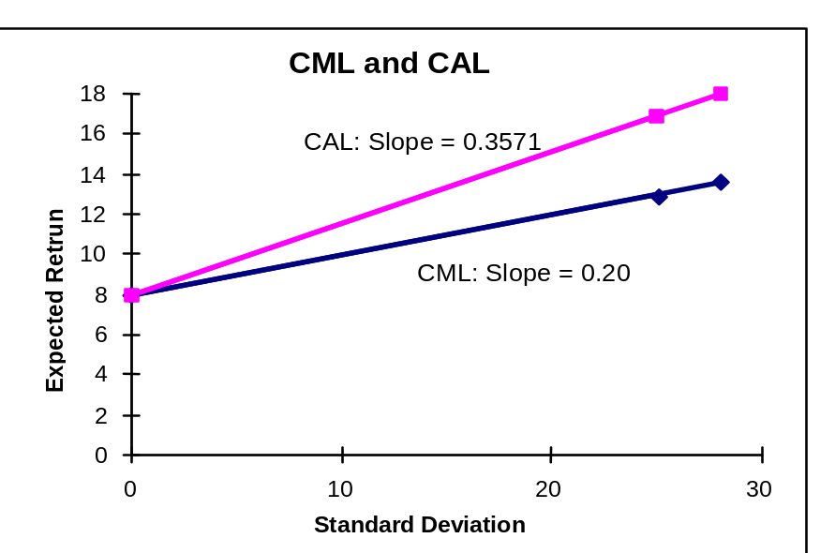

- My fund allows an investor to achieve a higher mean for any given standard deviation than would a passive strategy, i.e., a higher expected return for any given level of risk.

28. a. With 70% of his money invested in my fund’s portfolio, the client’s expected return is 15% per year with a standard deviation of 19.6% per year. If he shifts that money to the passive portfolio (which has an expected return of 13% and standard deviation of 25%), his overall expected return becomes:
E(r_{C}) = r_{f} + 0.7 × [E(r_{M}) − r_{f}] = .08 + [0.7 × (.13 – .08)] = .115, or 11.5%
The standard deviation of the complete portfolio using the passive portfolio would be:
σ_{C} = 0.7 × σ_{M} = 0.7 × 25% = 17.5%
Therefore, the shift entails a decrease in mean from 15% to 11.5% and a decrease in standard deviation from 19.6% to 17.5%. Since both mean return and standard deviation decrease, it is not yet clear whether the move is beneficial. The disadvantage of the shift is that, if the client is willing to accept a mean return on his total portfolio of 11.5%, he can achieve it with a lower standard deviation using my fund rather than the passive portfolio.
To achieve a target mean of 11.5%, we first write the mean of the complete portfolio as a function of the proportion invested in my fund (y):
E(r_{C}) = .08 + y × (.18 − .08) = .08 + .10 × y
Our target is: E(r_{C}) = 11.5%. Therefore, the proportion that must be invested in my fund is determined as follows:
.115 = .08 + .10 × y ⇒ 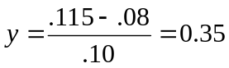
The standard deviation of this portfolio would be:
σ_{C} = y × 28% = 0.35 × 28% = 9.8%
Thus, by using my portfolio, the same 11.5% expected return can be achieved with a standard deviation of only 9.8% as opposed to the standard deviation of 17.5% using the passive portfolio.

b. The fee would reduce the reward-to-volatility ratio, i.e., the slope of the CAL. The client will be indifferent between my fund and the passive portfolio if the slope of the after-fee CAL and the CML are equal. Let f denote the fee:
Slope of CAL with fee 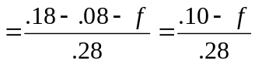
Slope of CML (which requires no fee)
Setting these slopes equal we have:
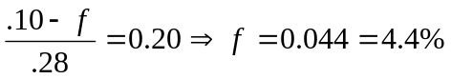per year

29. a. The formula for the optimal proportion to invest in the passive portfolio is:
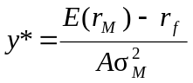
Substitute the following: E(r_{M}) = 13%; r_{f} = 8%; σ_{M} = 25%; A = 3.5:
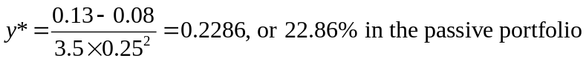

b. The answer here is the same as the answer to Problem 28(b). The fee that you can charge a client is the same regardless of the asset allocation mix of the client’s portfolio. You can charge a fee that will equate the reward-to-volatility ratio of your portfolio to that of your competition.

CFA PROBLEMS

1. Utility for each investment = E(r) – 0.5 × 4 × σ²
We choose the investment with the highest utility value, Investment 3.
Investment | Expected return E(r) | Standard deviation  σ | Utility  U
1 | 0.12 | 0.30 | -0.0600
2 | 0.15 | 0.50 | -0.3500
3 | 0.21 | 0.16 | 0.1588
4 | 0.24 | 0.21 | 0.1518

2. When investors are risk neutral, then A = 0; the investment with the highest utility is Investment 4 because it has the highest expected return.

3. (b)

4. Indifference curve 2 because it is tangent to the CAL.

5. Point E

6. (0.6 × $50,000) + [0.4 × (−$30,000)] − $5,000 = $13,000

7. (b) Higher borrowing rates will reduce the total return to the portfolio and this results in a part of the line that has a lower slope.

8. Expected return for equity fund = T-bill rate + Risk premium = 6% + 10% = 16%
Expected rate of return of the client’s portfolio = (0.6 × 16%) + (0.4 × 6%) = 12%
Expected return of the client’s portfolio = 0.12 × $100,000 = $12,000
(which implies expected total wealth at the end of the period = $112,000)
Standard deviation of client’s overall portfolio = 0.6 × 14% = 8.4%

9. Reward-to-volatility ratio = 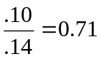

CHAPTER 6: APPENDIX

- By year-end, the $50,000 investment will grow to: $50,000 × 1.06 = $53,000
Without insurance, the probability distribution of end-of-year wealth is:
 | Probability | Wealth
No fire | 0.999 | $253,000
Fire | 0.001 | 53,000
For this distribution, expected utility is computed as follows:
E[U(W)] = [0.999 × ln(253,000)] + [0.001 × ln(53,000)] = 12.439582
The certainty equivalent is:
W_{CE} = e ^{12.439582} = $252,604.85
With fire insurance, at a cost of $P, the investment in the risk-free asset is:
$(50,000 – P)
Year-end wealth will be certain (since you are fully insured) and equal to:
[$(50,000 – P) × 1.06] + $200,000
Solve for P in the following equation:
[$(50,000 – P) × 1.06] + $200,000 = $252,604.85 ⇒ P = $372.78
This is the most you are willing to pay for insurance. Note that the expected loss is “only” $200, so you are willing to pay a substantial risk premium over the expected value of losses. The primary reason is that the value of the house is a large proportion of your wealth.

- a. With insurance coverage for one-half the value of the house, the premium is $100, and the investment in the safe asset is $49,900. By year-end, the investment of $49,900 will grow to: $49,900 × 1.06 = $52,894
If there is a fire, your insurance proceeds will be $100,000, and the probability distribution of end-of-year wealth is:
 | Probability | Wealth
No fire | 0.999 | $252,894
Fire | 0.001 | 152,894
For this distribution, expected utility is computed as follows:
E[U(W)] = [0.999 × ln(252,894)] + [0.001 × ln(152,894)] = 12.4402225
The certainty equivalent is:
W_{CE} = e ^{12.4402225} = $252,766.77

- With insurance coverage for the full value of the house, costing $200, end-of-year wealth is certain, and equal to:
[($50,000 – $200) × 1.06] + $200,000 = $252,788
Since wealth is certain, this is also the certainty equivalent wealth of the fully insured position.

- With insurance coverage for 1½ times the value of the house, the premium is $300, and the insurance pays off $300,000 in the event of a fire. The investment in the safe asset is $49,700. By year-end, the investment of $49,700 will grow to: $49,700 × 1.06 = $52,682
The probability distribution of end-of-year wealth is:
 | Probability | Wealth
No fire | 0.999 | $252,682
Fire | 0.001 | 352,682
For this distribution, expected utility is computed as follows:
E[U(W)] = [0.999 × ln(252,682)] + [0.001 × ln(352,682)] = 12.4402205
The certainty equivalent is:
W_{CE} = e ^{12.440222} = $252,766.27
Therefore, full insurance dominates both over- and underinsurance. Overinsuring creates a gamble (you actually gain when the house burns down). Risk is minimized when you insure exactly the value of the house.

